The MTPT Project’s
Cradle to Classroom Programme of Parental Transition Support

Promoting our Programmes – Guidance

Contents

Please use this document to promote our Cradle to Classroom programmes in your settings and networks.

NB: anything in red needs you attention and adapting as appropriate to your context.

Page
2 | An introduction to The MTPT Project’s Cradle to Classroom Programme of Parental Transition Support
4 | Funding criteria
6 | Full list of dates, raw links and social media handles
9 | Promoting the full Cradle to Classroom Programme
14 | Promoting our Parental Leave group coaching programme
19 | Promoting our Return to Work workshops
24 | Promoting our Sustain and Grow group coaching programme
29 | A checklist for the academic year
33 | Key marketing insights
37 | Funders by Region
39 | FAQs

Introduction



The MTPT Project
The MTPT Project is the UK’s charity for parent-educators, working to address the damaging impact of the motherhood penalty on our workforce, and transform teaching into one of the most family- and life-friendly careers available.

We are the leading voice for the parent-educator community, co-authoring the landmark Missing Mothers report in 2024, which strongly influenced the 2025 Teaching Commission Report, and the 2026 DfE White Paper, which placed women aged 30-39 and maternity returners at the heart of our retention and workforce conversations.

Around 15,000 teachers and teaching assistants take a period of maternity or paternity leave every year. We lose 5,456 of these colleagues in the four years following their return from maternity and extended paternity leave.

This loss is particularly acute in the first year of the return to work, where 18% of each maternity cohort – almost 2,000 teachers – are lost every year (MTPT, 2025). The inequality of our parental leave and pay policies lag far behind other graduate professions and embed gendered parenting roles.

Pregnancy and maternity discrimination, and discrimination on the grounds of sex remain hugely problematic in our schools, and is often compounded for single parents, colleagues from minoritised backgrounds and the LGBTQ+ community.

Cradle to Classroom
The MTPT Project’s Cradle to Classroom programme of parental transition support provides coaching and workshop support to educators as they become parents and in the first five years following their return to work and is enriched by online and in-person networking events.

A fourth programme – a block of x 4 1:1 coaching sessions – is available, funded according to certain criteria.

The Cradle to Classroom programmes are open to teachers, leaders, support staff, central Trust colleagues, supply teachers, and returners to the profession who have taken an extended caring related career break. We welcome participants of all parenting identities, not just mothers.

Since 2021, more than 1,300 parent-educators have benefited from one or more of our Cradle to Classroom programmes, and we know that coaching can improve wellbeing, occupational mobility and retention in the post-parental leave period, and support the negotiation of different flexible and full-time working patterns.

Funding Criteria

We are determined that our programmes remain fully funded for state school colleagues to support them at a time when parental leave and pay and childcare costs places financial strain on families.

Our Parental Leave group coaching programmes and Return to Work workshops are fully funded for all state school colleagues in England.

Our Sustain and Grow group coaching programme is available for state school colleagues in most regions. However, as of July 2026, some regions remain unfunded.

Funded counties / London boroughs |  | Unfunded counties / London boroughs – no funded access to Sustain and Grow
Bedfordshire  Berkshire  Birmingham  Cambridgeshire  Cheshire  Cornwall  Cumbria  Derbyshire  Devon  Durham  East Sussex  Essex Gloucestershire  Greater Manchester  Hertfordshire  Kent  Lancashire  Merseyside  Norfolk  Northamptonshire  North Yorkshire  Nottinghamshire  Oxfordshire  Shropshire  Staffordshire  South Yorkshire  Suffolk | Surrey  Tyne-and-Wear  Warwickshire  West Sussex  West Yorkshire  Wiltshire  Worcestershire  Bexley  Bromley  Croydon  Enfield  Greenwich  Havering  Kingston-upon-Thames  Lambeth  Lewisham  Newham  Redbridge  Richmond-upon-Thames Southwark  Sutton  Tower Hamlets  The City of London  Waltham Forest | Dorset  East Riding of Yorkshire  Hampshire  Herefordshire  Lincolnshire  Northumberland  Somerset  Barking and Dagenham  Barnet  Brent  Camden  Ealing  Enfield  Hackney  Harrow  Hammersmith and Fulham  Hillingdon  Hounslow  Islington  Kensington and Chelsea  Merton  Wandsworth

NASUWT members can enjoy fully funded access to Sustain and Grow even if they work in unfunded regions.

Staff working in independent or international schools, in Scotland, Wales, Northern Ireland or unfunded regions can join the programme with a paid-for place:

- Parental Leave group coaching - £120 per participant
- Return to Work workshops - £45 per participant
- Sustain and Grow group coaching - £240 per participant

Full list of dates, raw links and social media handles

Autumn – Cradle to Classroom  Parental Leave group coaching (Autumn) – 09:30-10:30  - Tuesday 15th September  - Tuesday 13th October  - Tuesday 10th November  Sustain and Grow (Tuesday) – 15:30-16:30  - Tuesday 22nd September  - Tuesday 6th October  - Tuesday 10th November  - Tuesday 1st December  - Tuesday 12th January  - Tuesday 2nd February  Sustain and Grow (Thursday) – 15:30-16:30  - Thursday 24th September  - Thursday 8th October  - Thursday 12th November  - Thursday 3rd December  - Thursday 14th January  - Thursday 4th February  Return to Work Workshop – 09:30-11:00  - Thursday 1st October  Return to Work Workshop – 09:30-11:00  - Monday 7th December  Parental Leave group coaching (Winter) –  09:30-10:30  - Friday 4th December  - Friday 8th January  - Friday 5th February | Autumn - Further Opportunities  Supporting Trainees who are Parents (Mentor workshop) – 15:30-16:30  - Thursday 10th September  In-person training opportunity – please enquire  - 21st October – 23rd October  Life Friendly Leadership (Winter Cohort) – 09:00-10:30 / 10:45-12:15  - Tuesday 17th November  - Tuesday 8th December  - Tuesday 12th January
Spring – Cradle to Classroom  Parental Leave group coaching (Winter) – 09:30-10:30  - Friday 4th December  - Friday 8th January  - Friday 5th February  Sustain and Grow (Tuesday) – 15:30-16:30  - Tuesday 19th January  - Tuesday 9th February  - Tuesday 9th March  - Tuesday 13th April  - Tuesday 11th May  - Tuesday 15th June  Sustain and Grow (Thursday) – 15:30-16:30  - Thursday 21st January  - Thursday 11th February  - Thursday 11th March  - Thursday 15th April  - Thursday 13th May  - Thursday 17th June  Return to Work Workshop – 09:30-11:00  - Tuesday 26th January  Parental Leave group coaching (Spring) –  09:30-10:30  - Thursday 11th March  - Thursday 15th April  - Thursday 13th May  Return to Work Workshop – 09:30-11:00  - Tuesday 9th March | Spring - Further Opportunities  Creating Family Friendly Schools (Annual Conference) – 09:30-12:30  - Friday 29th January  - Saturday 30th January  In-person training opportunity – please enquire  - 22nd February – 5th March
Summer – Cradle to Classroom  Parental Leave group coaching (Early Summer) – 09:30-10:30  - Tuesday 25th May  - Tuesday 22nd June  - Tuesday 20th July  Return to Work Workshop – 09:30-11:00  - Tuesday 4th May  Return to Work Workshop – 09:30-11:00  - Tuesday 8th June  Parental Leave group coaching (Midsummer) – 14:00-15:00  - Friday 2nd July  - Friday 30th July  - Friday 27th August  Return to Work Workshop – 09:30-11:00  - Friday 9th July | Summer - Further Opportunities  In-person training opportunity – please enquire  - 19th April – 30th April  Life Friendly Leadership (Summer Cohort) – 09:00-10:30 / 10:45-12:15  - Friday 21st May  - Friday 18th June  - Friday 8th July  Trainee and Mentor workshops  - Tuesday 6th July (Mentors)  - Thursday 8th July (Trainees)  - Tuesday 20th July (Trainees)  Travel Dates  - 6th July – 21st July

Raw Links
MTPT Eventbrite Page (all programmes):
🔗 https://www.eventbrite.co.uk/o/emma-sheppard-13216314101

Parental Leave group coaching programme:
🔗 https://www.eventbrite.co.uk/cc/mtpt-parental-leave-group-coaching-cohorts-3435509

Return to Work workshops:
🔗 https://www.eventbrite.co.uk/cc/mtpt-return-to-work-workshops-3435429

Sustain and Grow group coaching:
🔗 https://www.eventbrite.co.uk/cc/sustain-and-grow-group-coaching-3463389

Details of the full Cradle to Classroom programme:
🔗 www.mtpt.org.uk/coaching

1:1 Coaching:
🔗 https://docs.google.com/forms/d/e/1FAIpQLSe6_uv9Lnge9IRod-aewoTNkylIxhVlfJRukvtdik6MG-2U3g/viewform?usp=sharing&ouid=115994341062535790202

All fliers, available for download:
🔗 https://www.mtpt.org.uk/cradle-to-classroom-fliers

Social Media Handles
Instagram: @mtptproject
BlueSky: @mtptproject (for signposting only – we do not use BlueSky much)
LinkedIn: https://www.linkedin.com/company/the-mtpt-project/
Facebook: tag @The MTPT Project

Please note: The MTPT Project can be tagged on X @mtpt_project but we no longer use this social media platform.

Promoting the full Cradle to Classroom Programme

In this section, you will find content to promote the full Cradle to Classroom programme on different channels.

Please note: text in red must be changed according to your context (e.g. location, funder). You can find your regional funder on p. of this document.

What? | When? | Where? | How often?
A4 C2C Poster | September | Staff rooms  Photocopying rooms  Staff CPD board / noticeboard  Maternity, paternity, adoption, shared parental leave and flexible working policy documents | Once – integrate this into all family policies
Announcement blog | Autumn term | Newsletters  Websites  Blogging platforms | Once
“New to The MTPT Project” – Email content | Throughout the year | To HR / SLT colleagues  To wider leadership networks  To champions of The MTPT Project’s work | Termly
Social Media Announcement | Throughout the year | Instagram  X  BlueSky  LinkedIn  Facebook | Termly

2026-27 Announcement Blog

[FUNDER] Commits to Ongoing Support for Parent-Colleagues

Colleagues on a period of parental leave, returning to work or balancing their school commitments with young children will continue to benefit from fully funded support in the 2026-27 academic year thanks to an ongoing partnership between [FUNDER] and The MTPT Project.

This partnership will give state school colleagues fully-funded access to The MTPT Project’s Cradle to Classroom programme of transition support – three coaching and workshop offers designed to support them as they navigate their parenting journey:

- Group coaching during the parental leave period
- Return to Work workshops
- Group coaching (Sustain and Grow) for colleagues back at work with children aged 5 or younger

Each year, 15,000 teachers and teaching assistants begin a period of parental leave, but 36% of them leave the profession within the four years following their return. Rates are highest amongst teachers, with 18% of each maternity cohort leaving within the first 12 months of their return.

Recent research from TeacherTapp highlighted the challenges associated with taking a period of maternity, adoption or shared parental leave: confusion over legal entitlements during this period, challenges around flexible working and leadership roles, barriers to progression and feeling ‘forgotten’ or ‘like a spare part’ when returning after time out.

It’s no wonder then, that women aged 30-39 make up the largest group of teachers to leave the profession every year with The MTPT Project and New Britain Project’s Missing Mothers report finding that motherhood had a lot to do with this attrition.

[FUNDER] recognises the importance of supporting colleagues as they navigate this exciting new chapter of their lives. We want colleagues in our region to know how valuable they are to our schools, and to feel empowered to balance parenting with a career they love.

The MTPT Project’s Cradle to Classroom programme is designed to address the challenges faced by colleagues at different stages of their parenting journeys. The coaching and workshops are positive, empowering and offer participants the tools to fully enjoy both their personal and professional lives.

SENCO and teacher Rachel, who works in a London PRU, completed a recorded version of the Parental Leave group coaching programme during her maternity leave. She said:

“I really enjoyed the opportunity to reflect on my strengths as a teacher and as a parent. It is easy to be self-critical and being on maternity leave has made me really nervous about my ability to teach on my return, but these sessions gave me time to pause and think about my strengths.
“The coaching sessions offered me time to explore parts of myself that I hadn't expected to consider on the course. I also loved that there are so many opportunities outside of the course that I can use. I have already signed up for a return to work workshop in March, I'm going to ask to be added to a regional WhatsApp group, and I'd like to join the book club.

“It was really helpful to be able to complete these at my own time and pace using the recorded sessions.”

At the end of her first maternity leave, Claudia, a primary Lead Teacher based in London attended a Return to Work workshop. She said:

“All return to work colleagues are offered this workshop as a KIT day by our HR department. It was super informative and empowering. It made me feel that I can take my return to work into my own hands and ask for what I need. It's also really reassuring to hear about all the organisations that exist to support parents.”

Ben, a KS4 English Coordinator based in Essex completed the Sustain and Grow programme just before his second child was born. He said:

“Our coach was very friendly and engaging. It was so lovely to see coaching programmes like this out there! A wonderful experience.”

Since 2024, more than 1,300 colleagues like Rachael, Claire and Ben have attended one or more of the Cradle to Classroom programmes. We look forward to supporting even more new parents next academic year.

Upcoming dates for all three programmes in The MTPT Project’s 2025-26 Cradle to Classroom programme are available on Eventbrite.

Keep up to date by signing up to [FUNDER’s] newsletter, following us on [SOCIALS] or signing up to The MTPT Project’s fortnightly bulletin.

“New to The MTPT Project” – Email Content

Dear…

[FUNDER] are very excited to be supporting The MTPT Project’s Cradle to Classroom programme of parental transition support this academic year.

The programme consists of coaching and workshop opportunities to support colleagues over the parental leave and return to work period.

An information video outlining the programme, and the best way that you can share this with colleagues in your network is available here:

🔗 https://youtu.be/kMTNPBZuX0k

2026-27 Announcement Social Media

Instagram: @mtptproject
BlueSky: @mtptproject (for signposting only – we do not use BlueSky much)
LinkedIn: https://www.linkedin.com/company/the-mtpt-project/
Facebook: tag @The MTPT Project

Please note: The MTPT Project can be tagged on X @mtpt_project but we no longer use this social media platform.

Download an A4 poster or social media square here.

Instagram / BlueSky / X:

[FUNDER] commits to ongoing support for parent-educators! The @mtptproject’s Cradle to Classroom programme of parental transition support will be fully-funded for state school colleagues in [REGION] next year. Find out more at www.mtpt.org.uk/coaching

OR Find out more at [LINK TO 2026-27 ANNOUNCEMENT BLOG]

LinkedIn / Facebook:

[FUNDER] commits to ongoing support for parent-educators!

Colleagues on a period of parental leave, returning to work or balancing their school commitments with young children will continue to benefit from fully-funded support next academic year thanks to an ongoing partnership between [FUNDER] and @The MTPT Project.

This partnership will give state school colleagues fully-funded access to The MTPT Project’s Cradle to Classroom programme of transition support – three coaching and workshop offers designed to support them as they navigate their parenting journey:

- Group coaching during the parental leave period
- Return to Work workshops
- Group coaching (Sustain and Grow) for colleagues back at work with children aged 5 or younger

Find out more at www.mtpt.org.uk/coaching

OR Find out more at [LINK TO 2026-27 ANNOUNCEMENT BLOG]

Promoting our Parental Leave group coaching programme

In this section, you will find content to promote our Parental Leave group coaching programme on different channels.

N.B. This is our most “hard to reach” audience, as they do not check their school emails whilst on leave, and are otherwise distanced / isolated from their professional communities.

In our Life Friendly Leadership programme, we share systems to prepare colleagues effectively for an empowered parental leave and smooth reintegration into work before they take a period of leave.

Please note: text in red must be changed according to your context (e.g. location, funder). You can find your regional funder on p. of this document.

What? | When? | Where? | How often?
A4 C2C Poster | September  In risk assessment / third trimester meeting  During KIT day conversations (where colleagues still have at least 4 months of leave remaining) | Staff rooms  Photocopying rooms  Staff CPD board / noticeboard  Maternity, paternity, adoption, shared parental leave and flexible working policy documents | Once – integrate this into all family policies
Case Study | Autumn 2 onwards | Newsletters  Websites  Blogging platforms | Termly
Direct invitation – Email content | Before colleagues leave for parental leave  Once when in contact with colleagues during their leave | Email | Termly
Social Media Announcement | July  November  January  February  April  June | Instagram  X  BlueSky  LinkedIn  Facebook | Once at the start of each month indicated

Case Study – Parental Leave group coaching

Empowering group coaching for your maternity, adoption or shared parental leave

[FUNDER] are proud to collaborate with Teaching School Hubs, headteacher networks, multi-academy trusts, unions and national partners across England to provide fully funded access to The MTPT Project’s Parental Leave Group Coaching Programme to state school colleagues in [REGION].

This three-session programme offers colleagues in [REGION] empowering group coaching when they are on maternity, adoption or shared parental leave, or when they are re-entering the profession after a caring-related career break.

Ensuring the programme is fully-funded for state school colleagues is just one of the ways that [FUNDER] is addressing the recommendation in the recent Missing Mothers report by The New Britain Project and The MTPT Project, which called for “a comprehensive coaching programme for mothers during, and post-maternity leave”.

Each year, 15,000 teachers and teaching assistants begin a period of parental leave, and – as joyful as starting or growing a family can be – many report feeling isolated or as if they have lost themselves a little in the busy months of early parenthood.

The MTPT Project’s Parental Leave group coaching programme provides community, protected time for new parents to put themselves first, and the headspace to reconnect with themselves and navigate their parental leave with confidence.

Since 2024, more than 170 colleagues have completed the programme, many of whom have then gone on to attend a Return to Work workshop and complete The MTPT Project’s Sustain and Grow group coaching programme when they are back at work.

Feedback from participants shows that our Parental Leave group coaching programme makes a positive impact in their personal and professional lives. It helps them to feel more optimistic during their parental leave, gives them the space to clarify their values and priorities, and motivates them to work towards the goals they set themselves.

The group coaching also provides the opportunity to widen professional networks, and gives participants the confidence to make and negotiate flexible working requests and organise KIT days, so that they feel more in control of their eventual return to work.

Both primary teacher Nicola and secondary English teacher Danielle completed the programme in 2025.

Nicola said: “It was well structured, insightful and helped me to reflect on myself, where I am at and where I would like to be in all different areas of my life and has given me the confidence to dream big! It was also wonderful to meet other parents who are in a similar position to me and helped me feel not alone in the feelings of anxiety as I head back into the workplace after my second maternity leave.”

Danielle said: “It was really valuable to connect with other parents in the same position who understand exactly how it feels to be a mother and a teacher. It was great to have some time for myself to focus on what I want for my maternity leave, when I return to work and the future. Knowing there was the option to complete a live or hybrid version of the programme helped because I knew that if I was unable to attend live, I wouldn't miss out completely.”

Find out more about The MTPT Project’s fully-funded Parental Leave group coaching, including upcoming cohort dates and other regional funders on Eventbrite.

Direct invitation – Email Content

Adapt as you see fit according to your relationship with the recipient.

Dear…

Congratulations on your expectancy / pregnancy / upcoming leave / I hope that this email finds you well and enjoying maternity / adoption / shared parental leave. [Add something personalised here if appropriate].

I’m getting in touch to draw your attention to a fully funded coaching offer that may be of interest to you during your leave.

The MTPT Project are the UK’s charity for parent-educators, and they run a three-month group coaching programme called for colleagues currently on maternity, adoption or shared parental leave.

The programme is completely optional, and designed to support you personally during your leave, giving you some “me time” for your own thoughts and goals. It has received lots of positive feedback from previous participants who have used it to stay connected with a supportive community of educators during their leave and explore their new identities as parents. We consider this professional and personal development and you get a certificate at the end from The MTPT Project.

There are live, hybrid and recorded options to complete the programme, which takes place on Zoom and is fully funded by [FUNDER].

You can see the dates of upcoming cohorts on Eventbrite: https://www.eventbrite.co.uk/cc/mtpt-parental-leave-group-coaching-cohorts-3435509

You can sign up directly without going through me / anyone else at school, but please feel free to share or celebrate anything you’d like with us as we stay in touch during your leave.

Parental Leave Social Media

Instagram: @mtptproject
BlueSky: @mtptproject (for signposting only – we do not use BlueSky much)
LinkedIn: https://www.linkedin.com/company/the-mtpt-project/
Facebook: tag @The MTPT Project

Please note: The MTPT Project can be tagged on X @mtpt_project but we no longer use this social media platform.

Download a Parental Leave group coaching flier here.

Instagram / BlueSky / X:

Colleagues currently on a period of parental leave can enjoy fully funded access to @mtptproject’s Parental Leave group coaching programme. Book your place at: https://www.eventbrite.co.uk/cc/mtpt-parental-leave-group-coaching-cohorts-3435509 Next live cohort begins [DATE]

LinkedIn / Facebook:

Colleagues currently on a period of maternity, adoption or shared parental leave can enjoy fully funded access to @The MTPT Project’s Parental Leave group coaching programme.

Live, recorded or hybrid access to the programme gives you an hour of “me time” each month to consider your own identity, reflections and goals with a supportive cohort of parent-educators.

Live, hybrid and recorded access are available, and places are fully funded for state school colleagues by [FUNDER]. The next live cohort begins [DATE]

Book your place at: https://www.eventbrite.co.uk/cc/mtpt-parental-leave-group-coaching-cohorts-3435509

Promoting our Return to Work workshops

In this section, you will find content to promote our Return to Work workshops on different channels.

N.B. This is our most popular, and well-received programme and makes a huge difference to the returner experience.

In our Life Friendly Leadership programme, we share ways to create effective return to work systems to boost wellbeing and reduce attrition in the first year back to work. For every 5 teachers who take a period of maternity leave in your setting, one is likely to leave in this first 12 months of their return.

Please note: text in red must be changed according to your context (e.g. location, funder). You can find your regional funder on p. of this document.

What? | When? | Where? | How often?
A4 C2C Poster | September  During KIT day conversations | Staff rooms  Photocopying rooms  Staff CPD board / noticeboard  Maternity, paternity, adoption, shared parental leave and flexible working policy documents | Once – integrate this into all family policies
Case Study | Autumn 1 onwards | Newsletters  Websites  Blogging platforms | Termly
Direct invitation – Email content | The term before colleagues are due to return to work  When organising KIT days | Email | Twice
Social Media Announcement | September  November  January  February  April  May  June  July | Instagram  X  BlueSky  LinkedIn  Facebook | Once at the start of each month indicated

Case Study – Return to Work workshop

A confident return to work from maternity, adoption or shared parental leave

[FUNDER] are proud to collaborate with Teaching School Hubs, headteacher networks, multi-academy trusts, unions and national partners across England to provide fully funded access to The MTPT Project’s Return to Work workshops to state school colleagues in [REGION].

This 90-minute online workshop offers colleagues in [REGION] important information about their entitlements as returning parents, and prepares them logistically and emotionally for their return. Returning parents can access a live or recorded version of the workshop to best suit their schedules.

Ensuring the programme is fully-funded for state school colleagues is just one of the ways that [FUNDER] is responding pro-actively to the finding in the 2024 Missing Mothers report that revealed that just 38% of colleagues who had remained in the profession following their maternity leave were satisfied with the transition support that they received from their school.

Each year, 15,000 teachers and teaching assistants begin a period of parental leave, but in the first year back to work, we lose 16% of each parental leave cohort – more than 2,400 educators in total. This 12-month attrition rate is highest amongst teachers who have taken a period of maternity leave (18%) or extended paternity leave (14%).

The MTPT Project’s Return to Work workshop empowers staff at this time by ensuring they know their legal entitlements, and the ways that they can take control of their return to work experience.

Since 2024, more than 630 colleagues have completed the programme, many of whom engaged with The MTPT Project’s Parental Leave group coaching programme, and go on to complete our Sustain and Grow group coaching programme when they are back at work.

Feedback from participants shows that our Return to Work workshops make a positive impact in their personal and professional lives. It helps them to clarify their boundaries, gives them tips to balance their work and home lives and the knowledge and tools to recognise and tackle discrimination if it occurs.

Professionally, the workshops boost returning parents’ confidence when communicating with line managers about their needs, improves their understanding of relevant policy documents, and helps them to plan KIT and SPLIT day opportunities.

Head of MFL, Fleur and Deputy Head, Hannah, both completed a workshop in 2025.

Fleur said: “It was great to have some time to really think about returning to work without interruption and with the support of the facilitator and the other parents on the call. Usually, I think about it and then those thoughts are interrupted, but I had a decent amount of time to focus. The concrete examples given were brilliant as my head feels very full and so thinking straight isn't always easy at the moment!”

Hannah said: “The workshop was very clear and informative. I liked the breakout rooms as a chance to chat and compare experiences with colleagues, and loved the boundary setting coaching activity.”

Returning to work after an extended period of parental leave might feel daunting, but The MTPT Project’s Return to Work workshops and supportive community can help you to navigate this big step with confidence.

Find out more about our fully funded workshops, including upcoming live dates and details about our regional funders on Eventbrite.

Direct invitation – Email Content

Adapt as you see fit according to your relationship with the recipient.

Dear…

We are really looking forward to seeing you on your next KIT day / when you return to work in the coming weeks / months. [Add something personalised here if appropriate.]

To support you as you make this big transition, could I draw your attention to the fully-funded Return to Work workshops run by The MTPT Project, the UK’s charity for parent-educators?

The workshop highlights your legal entitlements as a returning parent and offers you some group coaching space to explore your emotional and logistical preparation ahead of your return. It also gives you the chance to meet other educators who are also returning to work soon to share your experiences.

The workshop is completely optional, fully-funded by [FUNDER] and can be completed at home [or when you are in school for a KIT day on [DATE]]. There are live and recorded access versions available, and feedback from previous participants has been really positive.

The next live workshop takes place on [DATE]. More information is available on Eventbrite: https://www.eventbrite.co.uk/cc/mtpt-return-to-work-workshops-3435429

You can sign up directly without going through me / anyone else at school, but do let me know if you’d like to book in a meeting to discuss any questions that arise from the workshop if you do choose to attend.

Return to Work workshop Social Media

Instagram: @mtptproject
BlueSky: @mtptproject (for signposting only – we do not use BlueSky much)
LinkedIn: https://www.linkedin.com/company/the-mtpt-project/
Facebook: tag @The MTPT Project

Please note: The MTPT Project can be tagged on X @mtpt_project but we no longer use this social media platform.

Download a Return to Work workshop flier here.

Instagram / BlueSky / X:

Colleagues preparing to return to work following a period of parental leave can enjoy fully funded access to @mtptproject’s Return to Work workshop. Next live workshop date: [DATE] Recorded access available if you can’t join live.

Book your place at: https://www.eventbrite.co.uk/cc/mtpt-return-to-work-workshops-3435429

LinkedIn / Facebook:

Colleagues preparing to return to work following a period of maternity, adoption or shared parental leave can enjoy fully funded access to @themtptproject’s next live Return to Work workshop on [DATE].

This 90-minute webinar shares key legal information and gives you the space to emotionally and logistically prepare for a confident return. Recorded access is available if you can’t join live.

If you’ve got colleagues returning to work this half term, this is a brilliant way to show them they are valued and offer them practical support as they make this big transition.

Find out more and book your place at: https://www.eventbrite.co.uk/cc/mtpt-return-to-work-workshops-3435429

Promoting our Sustain and Grow group coaching programme

In this section, you will find content to promote our Sustain and Grow group coaching programme on different channels.

A reminder that this programme is for colleagues who are back at work with children aged 5 or younger, and is suitable for fathers / non-birthing partners who have

In our Life Friendly Leadership programme, we share ways to create effective return to work systems to boost wellbeing and reduce attrition in the first year back to work. For every 5 teachers who take a period of maternity leave in your setting, one is likely to leave in this first 12 months of their return.

Please note: text in red must be changed according to your context (e.g. location, funder). You can find your regional funder on p. of this document.

What? | When? | Where? | How often?
A4 C2C Poster | September  During KIT day conversations | Staff rooms  Photocopying rooms  Staff CPD board / noticeboard  Maternity, paternity, adoption, shared parental leave and flexible working policy documents | Once – integrate this into all family policies
Case Study | July onwards | Newsletters  Websites  Blogging platforms | Termly
Direct invitation – Email content | July / September  December  During KIT day conversations | Email | Twice
Social Media Announcement | July / summer holidays / September  December / January | Instagram  X  BlueSky  LinkedIn  Facebook | Once at the start of each month / period indicated

Case Study – Sustain and Grow group coaching

Find a sense of balance between your work and family life with fully funded coaching from The MTPT Project

[FUNDER] are proud to collaborate with Teaching School Hubs, headteacher networks, multi-academy trusts, unions and national partners across England to provide fully funded access to The MTPT Project’s Sustain and Grow group coaching programme to state school colleagues in [REGION].

This six-session programme offers colleagues back at work with a child aged 5 or younger a monthly online coaching session exploring topics such as overwhelm, boundaries and values. Cohorts begin in September and January, and live, hybrid and recorded access options provide the flexibility to complete the programme around school and home commitments.

Ensuring the programme is fully-funded for state school colleagues is just one of the ways that [FUNDER] is responding pro-actively to the fact that educators aged 30-39 – predominantly female teachers – are the largest demographic to leave the profession every year. In fact, in the first four years following the return from maternity, paternity, adoption and shared parental leave, almost two fifths of teachers and teaching assistants leave the classroom.

The MTPT Project’s Sustain and Grow group coaching programme provides a safe and supportive space for colleagues as they navigate early parenthood alongside working in schools.

Since 2024, 190 colleagues have completed the programme, many of whom previously engaged with The MTPT Project’s Parental Leave group coaching programme, and Return to Work workshops.

Feedback from participants shows that our Sustain and Grow group coaching makes a positive impact in their personal and professional lives. It increases their self-awareness and understanding of their personal values, boosts confidence, and enables them to set and maintain clear boundaries.

Professionally, participants feel that the coaching improves their leadership and management skills, has helped them to reduce their workload and negotiate better working conditions to support them to balance work and family life.

Biology Teacher, Paul and KS5 Maths Coordinator, Kate, completed the programme in 2026.

Paul, who has two young children, said, “It was really valuable to learn lots of coaching techniques to help with the day-to-day aspects of teaching. It was also great to hear other colleagues worries and concerns in the breakout rooms - often these were similar or aligned with my own.”

Recent maternity-returner, Kate said: “It’s hard to create time to reflect and think hard about my professional and personal life without prompting and this programme gave me the monthly prompt I needed. The coaching style was efficient but also very calming and I left each session feeling positive and able to overcome the issues I am juggling.

“The other teachers in the session were thoughtful, kind and positive. Hearing their dilemmas and struggles helped me feel more positive about my own, and being part of a community of teacher parents helped me articulate some of the changes I have had to negotiate over the last few years. I genuinely have found that motherhood has allowed me to get a better work-life balance.”

Combining the demanding roles of parenting and working in schools can sometimes feel impossible, but Sustain and Grow gives you the tools to define what “balance” means to you, and the steps to secure this in a way that feels manageable and empowering.

Find out more about our fully funded coaching, including upcoming cohorts and details about our regional funders on Eventbrite.

Direct invitation – Email Content
Adapt as you see fit according to your relationship with the recipient.

Dear…

As a member of staff we know to have a young family / As you have recently returned from parental leave / As you are preparing to return to work soon, I wanted to draw your attention to a fully funded coaching offer that may be of interest to you, which starts this September / January.

The MTPT Project are the UK’s charity for parent-educators, and they run a six-month group coaching programme called Sustain and Grow for teachers, leaders and support staff who are parents.

The programme is completely optional, and absolutely nothing to do with any of our performance management at [SCHOOL / TRUST]. It is all about empowering you and giving you the time and headspace to explore topics that are relevant to you as a parent and professional, and set goals that are meaningful for your home and work life.

The programme has been running since 2023, and has received lots of positive feedback from participants around finding a sense of balance, setting boundaries and generally feeling uplifted and supported. It counts as professional and personal development and comes with a certificate at the end from The MTPT Project.

As your youngest child is less than 5 years old, you can access the programme, which is fully funded by [FUNDER].

Cohorts run on Tuesdays and Thursdays between 3:30-4:30pm on Zoom. Live dates are available on Eventbrite, and hybrid and recorded access are available if you can’t make some / any of them live: https://www.eventbrite.co.uk/cc/sustain-and-grow-group-coaching-3463389

You can sign up directly without going through me / anyone else at school, but I’d love to know if you choose to go ahead with it.

Sustain and Grow Social Media

Instagram: @mtptproject
BlueSky: @mtptproject (for signposting only – we do not use BlueSky much)
LinkedIn: https://www.linkedin.com/company/the-mtpt-project/
Facebook: tag @The MTPT Project

Please note: The MTPT Project can be tagged on X @mtpt_project but we no longer use this social media platform.

Download a Sustain and Grow group coaching flier here.

Instagram / BlueSky / X:

The @mtptproject’s Sustain and Grow group coaching offers fully funded group coaching to state school teachers in England who have children aged 5 or younger. Next cohort begins [DATE]. Book your place at: https://www.eventbrite.co.uk/cc/sustain-and-grow-group-coaching-3463389

LinkedIn / Facebook:

@The MTPT Project’s Sustain and Grow group coaching programme offers state school colleagues with children aged 5 or younger six sessions of group coaching to support you to find a sense of balance between your work and family life.

Monthly online live sessions run on Tuesday or Thursdays between 15:30-16:30. Hybrid and recorded access are available for those who can’t make every live date.

Sustain and Grow is fully funded for state school colleagues working in most regions in England.

The next cohort begins on [DATE]. Book your place on Eventbrite: https://www.eventbrite.co.uk/cc/sustain-and-grow-group-coaching-3463389

A checklist for the academic year

Summer 2026

When | What?
July | - Add A4 C2C Poster to maternity, paternity, adoption, shared parental leave and flexible working policy documents  - Share Sustain and Grow Case Study in newsletters, on websites and blogging platforms  - Send a direct email inviting colleagues with children aged 5 or under to explore the September cohorts of our Sustain and Grow group coaching programme  - Who is returning to work in September-October?  - Send a direct email inviting them to attend our July Return to Work workshop / access the recorded version  - Schedule Parental Leave group coaching posts on social media platforms  - Are you interested in The MTPT Project’s Life Friendly Leadership programme?  - Explore recorded access over the summer, or the dates of our November cohort  - Would you like an in-person training or coaching session from Founder, Emma Sheppard?  - Email mtptproject@gmail.com to enquire about October availability
August | - Schedule Cradle to Classroom / Sustain and Grow / Parental Leave group coaching posts on social media platforms  - Book your early bird ticket to The MTPT Project’s annual conference, Creating Family Friendly Schools – early bird offer ends 1st October!

A checklist for the academic year

Autumn 2026

September | - Display A4 C2C Poster in staff rooms, communal spaces, on noticeboards, and include in termly newsletter / staff bulletin  - Schedule Sustain and Grow coaching posts on social media platforms  - Who is returning to work in October-November?  - Send a direct email inviting them to attend our October Return to Work workshop / access the recorded version  - Share Return to Work Case Study in newsletters, on websites and blogging platforms  - Schedule Return to Work workshop posts on social media platforms  - Who is pregnant / expecting / beginning the adoption process? Don’t forget fathers and non-birthing partners!  - Send a direct email inviting them to explore our full Cradle to Classroom offer  - Who is currently on extended parental leave (maternity, adoption, shared parental leave)? Don’t forget fathers and non-birthing partners!  - Send a direct email inviting them to explore our Parental Leave group coaching programme – don’t email them about this again unless they express an interest
October | - Who is returning to work in December-January?  - Send a direct email inviting them to attend our December Return to Work workshop / access the recorded version  - Book your group ticket to The MTPT Project’s annual conference, Creating Family Friendly Schools – for you and your teams  - Are you interested in The MTPT Project’s Life Friendly Leadership programme?  - Explore the dates of our November cohort
November | - Schedule Return to Work workshop posts on social media platforms  - Share Parental Leave group coaching Case Study in newsletters, on websites and blogging platforms  - Schedule Parental Leave group coaching posts on social media platforms  - Would you like an in-person training or coaching session from Founder, Emma Sheppard?  - Email mtptproject@gmail.com to enquire about February / March / April availability
December | - Send a direct email inviting colleagues with children aged 5 or under to explore the September cohorts of our Sustain and Grow group coaching programme  - Schedule Sustain and Grow coaching posts on social media platforms  - Book your ticket to The MTPT Project’s annual conference, Creating Family Friendly Schools – sales end 28th January
A checklist for the academic year

Spring 2027

January | - MTPT begins funding conversations for 2027-28  - Schedule Sustain and Grow coaching posts on social media platforms  - Who is returning to work in February-March?  - Send a direct email inviting them to attend our January Return to Work workshop / access the recorded version  - Share Return to Work Case Study in newsletters, on websites and blogging platforms  - Schedule Return to Work workshop posts on social media platforms  - Who is pregnant / expecting / beginning the adoption process? Don’t forget fathers and non-birthing partners!  - Send a direct email inviting them to explore our full Cradle to Classroom offer  - Who is currently on extended parental leave (maternity, adoption, shared parental leave)? Don’t forget fathers and non-birthing partners!  - Send a direct email inviting them to explore our Parental Leave group coaching programme – don’t email them about this again unless they express an interest  - Schedule Parental Leave group coaching posts on social media platforms
February | - Who is returning to work in March-April?  - Send a direct email inviting them to attend our March Return to Work workshop / access the recorded version  - Schedule Return to Work workshop posts on social media platforms  - Share Parental Leave group coaching Case Study in newsletters, on websites and blogging platforms  - Schedule Parental Leave group coaching posts on social media platforms  - Are you beginning your trainee recruitment?  - Ask The MTPT Project about our summer workshops for trainees and mentors  - Are you interested in The MTPT Project’s Life Friendly Leadership programme?  - Explore the dates of our May cohort
March | - Who is pregnant / expecting / beginning the adoption process? Don’t forget fathers and non-birthing partners!  - Send a direct email inviting them to explore our full Cradle to Classroom offer  - Who is currently on extended parental leave (maternity, adoption, shared parental leave)? Don’t forget fathers and non-birthing partners!  - Send a direct email inviting them to explore our Parental Leave group coaching programme – don’t email them about this again unless they express an interest  - Would you like an in-person training or coaching session from Founder, Emma Sheppard?  - Email mtptproject@gmail.com to enquire about July availability
A checklist for the academic year

Summer 2027

April | - Who is returning to work in May-September?  - Send a direct email inviting them to attend our summer Return to Work workshop / access the recorded version  - Share Return to Work Case Study in newsletters, on websites and blogging platforms  - Schedule Return to Work workshop posts on social media platforms  - Share Parental Leave group coaching Case Study in newsletters, on websites and blogging platforms  - Schedule Parental Leave group coaching posts on social media platforms  - Are you interested in The MTPT Project’s Life Friendly Leadership programme?  - Explore the dates of our May cohort
May | - Schedule Return to Work workshop posts on social media platforms  - Who is pregnant / expecting / beginning the adoption process? Don’t forget fathers and non-birthing partners!  - Send a direct email inviting them to explore our full Cradle to Classroom offer  - Who is currently on extended parental leave (maternity, adoption, shared parental leave)? Don’t forget fathers and non-birthing partners!  - Send a direct email inviting them to explore our Parental Leave group coaching programme – don’t email them about this again unless they express an interest  - Sign up for The MTPT Project’s information event for 2027-28 programmes – look out for the invitation in your emails / on LinkedIn
June | - Schedule Return to Work workshop posts on social media platforms  - Schedule Parental Leave group coaching posts on social media platforms  - Are you interested in The MTPT Project’s Life Friendly Leadership programme?  - Explore our recorded access version over the summer
July | - Schedule Return to Work workshop posts on social media platforms

Key Marketing Insights

Your support in promoting our Cradle to Classroom programmes is essential to the positive impact that we can make as a community.

How participants hear about our Cradle to Classroom offer varies according to the different programmes, but School / MAT communication and “Recommended by a Friend” consistently appear in the top four marketing channels.

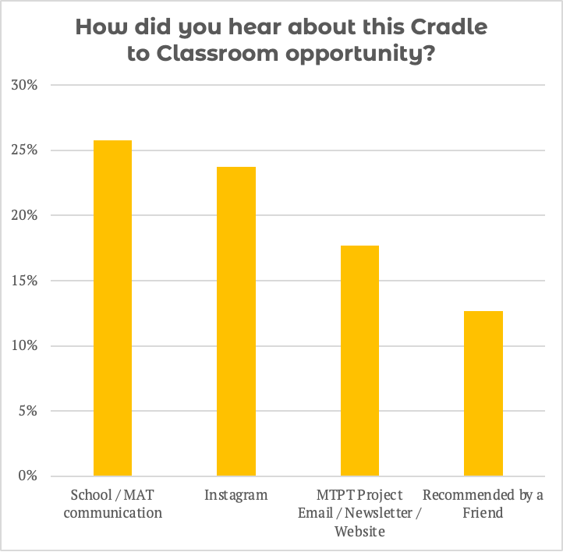

We especially see this in regions where The MTPT Project has strong and established relationships with schools, MATs and TSHs. In Hertfordshire, for example, where Chiltern TSH and Alban TSH have been working with The MTPT Project for a number of years, and beyond the Cradle to Classroom programme, 44% of participants heard about the programmes through “School / MAT communication”.

Once a handful of participants have a positive experience on a programme, engagement across regions is exponential. Participants recommend the programmes to their colleagues and friends, and they become embedded in the culture and practice of a school or community.

In Kent, for example, where engagement has been very high in 2025-26, 26% of participants across all programmes were recommended by a friend. In Cambridgeshire, a newly funded region for 2025-26, 43% of participants heard about our programmes through a friend or colleague.

Parental Leave group coaching
Our Parental Leave group coaching participants are our most “hard to reach” audience: they are not necessarily exposed to the communication within school communities and often do not yet know about The MTPT Project.

However, colleagues on parental leave are active on social media for their personal and professional lives and this is where they learn more about The MTPT Project and our programmes, often because a friend / colleague has recommended them to us.

Some clearly keep in touch with their school, and appreciate hearing about our Parental Leave group coaching programme in school communications.

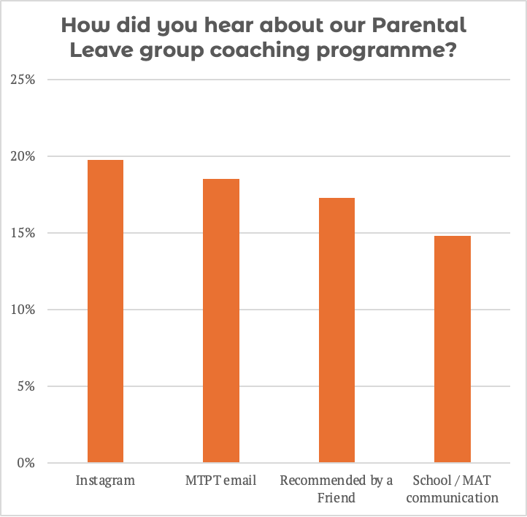

Return to Work workshops
Our Instagram community support us in promoting our Return to Work workshops, but participants are more likely to hear about this opportunity from their school, than from direct MTPT communication. It is highly likely that KIT days and effective HR and Line Manager communication play a part in this.
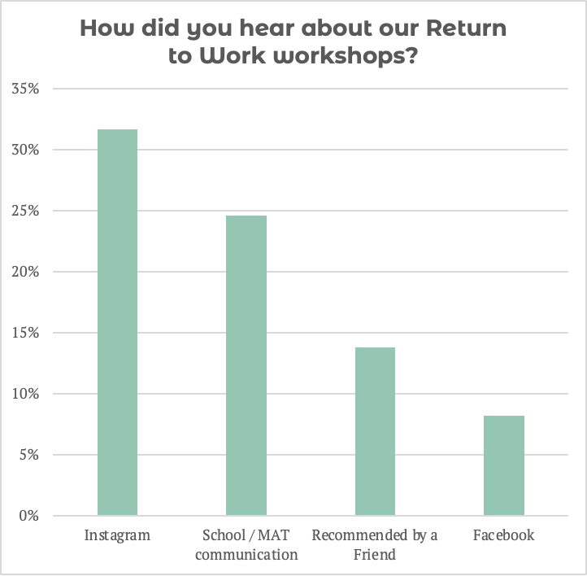

Sustain and Grow group coaching
It makes sense that our Sustain and Grow group coaching participants are most likely to hear about the programmes from their school or MAT – after all, this is an audience who are already back at work and interacting with emails, newsletters, announcements in briefings etc.

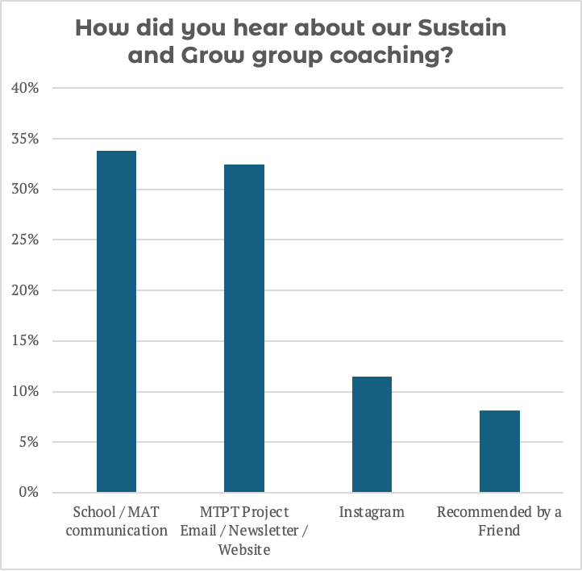

Many Sustain and Grow participants have also already engaged with The MTPT Project through our Parental Leave group coaching programme or Return to Work workshops, and here about our ongoing coaching offer at these events.

Funders by Region

Region | Funder | Region | Funder
Bedfordshire  Berkshire  Birmingham  Cambridgeshire  Cheshire  Cornwall  Cumbria  Derbyshire  Devon  Durham  East Sussex  Essex  Gloucestershire  Greater Manchester  Hertfordshire  Kent  Lancashire  Merseyside  Norfolk  Northamptonshire  North Yorkshire  Nottinghamshire  Oxfordshire  Shropshire | Chiltern TSH  TSH Berkshire  Star Institute  Haybridge High School  Cambridgeshire Secondary Headteachers Network  Cheshire TSH  TPAT  CELT  One Cumbria  Learners First  NEU Devon  SWIFT  Northern Lights Learning Trust  STEP Ahead TSH  Harris Institute  NEU Combined Districts (Thurrock, Essex West, Southend)  Odyssey TSH  Balcarras TSH  East Manchester TSH  Bright Futures TSH  Generate TSH  Alban TSH  Chiltern TSH  Combined NEU Districts (North, East, South and West Kent)  Star Institute  Embrace TSH  Inspire TSH  Rainbow TSH  Inspiration TSH  Northamptonshire TSH  Pathfinder TSH  Redhill TSH  OTSA  Shropshire and Telford Education Partnership (STEP) | Staffordshire  South Yorkshire  Suffolk  Surrey  Tyne-and-Wear  Warwickshire  West Sussex  West Yorkshire  Wiltshire  Worcestershire  Bexley  Bromley  Croydon  Enfield  Greenwich  Havering  Kingston-upon-Thames  Lewisham  Newham  Redbridge  Richmond-upon-Thames  Southwark  Sutton  Tower Hamlets and the City of London  Waltham Forest | The Mercian Trust  Learners First  Astrea MAT  Unity TSH  SFET TSH  Northern Lights Learning Trust  Coventry and Central Warwickshire TSH  Diocese of Chichester MAT  Combined NEU Districts (Calderdale, Leeds)  OTT SCITT  Central Region Schools Trust  Thames South TSH  Thames South TSH  Harris Institute  Harris Institute  Thames South TSH  Harris Institute  NEU Kingston-upon-Thames  Haberdashers’ Academies Trust South  NEU Newham  Harris Institute  NEU Richmond-upon-Thames  NEU Southwark  Harris Institute  NEU Tower Hamlets and City  Harris Institute

Our Parental Leave group coaching programmes and Return to Work workshops are funded in all regions in England for state school colleagues, including in the regions listed below. However, we do not have sufficient funding to offer funded access to our Sustain and Grow group coaching programme in these regions.

Unfunded regions – no funded access to Sustain and Grow
Dorset  East Riding of Yorkshire  Hampshire  Herefordshire  Lincolnshire  Northumberland  Somerset | Barking and Dagenham  Barnet  Brent  Camden  Ealing  Enfield  Hackney  Harrow | Hammersmith and Fulham  Hillingdon  Hounslow  Islington  Kensington and Chelsea  Merton  Wandsworth

We would welcome conversations with funders in these regions able to offer between £225 and £825 to open access to our Sustain and Grow group coaching programme. Please get in touch at mtptproject@gmail.com

FAQs

- Are programmes open to support staff / fathers / central Trust team members / colleagues returning to the profession after a caring-related career break?

Yes. The programmes are open to all parent-educators and funding is available for those working in state schools in England. Funding is unavailable for our Sustain and Grow group coaching programme in some regions. Please see pp.

- Are the programmes available for staff working in post-16 / colleges and nursery settings?

Yes, and funding is available for any colleagues working in state settings. If the DfE pays your wages, and your setting is subject to Ofsted, our funding includes you.

- A participant cannot attend all the live dates in a group coaching cohort.

That’s okay. Our hybrid and recorded access means that participants can complete some sessions live, and some sessions using the recorded version.

- Is funding available for staff working in independent schools, or schools in Wales, Scotland or Northern Ireland?

Not in most cases – please see FAQ #5 and #6 for exceptions.

We welcome colleagues working in independent schools onto our programmes, but our funding only covers the state sector in England. Please see p. for per-participant costs.

If you are an organisation that works with independent schools, we would welcome a funding contribution of £2,500 to pilot these programmes with independent school colleagues on a national scale.

If you are an organisation that works in Wales, Scotland or Northern Ireland, we would welcome a funding contribution of £2,500 per country to pilot these programmes.

- What about NASUWT members working in independent schools, or schools in Wales, Scotland or Northern Ireland?

All programmes are funded for NASUWT members, including colleagues working in independent schools, and schools in Wales, Scotland and Northern Ireland.

Where colleagues working in independent schools, or schools in Wales, Scotland and Northern Ireland sign up for Return to Work workshops, every effort will be made to ensure that the legalities shared are accurate to, and inclusive of independent schools, and conditions in Wales, Scotland and Northern Ireland, as these can vary from conditions in state schools in England.

- What about NEU members working in independent schools in regions where the NEU are a funding partner?

All programmes are funded for NEU members, including colleagues working in independent schools, in the following regions:

- Devon
- Thurrock, Essex West, Southend
- South Kent,
- Calderdale, Leeds
- Kingston-upon-Thames
- Newham
- Richmond-upon-Thames
- Tower Hamlets and City

- My organisation would like to make a funded contribution to cover an unfunded region.

Great! Contact us at mtptproject@gmail.com so we can send you more information.

- Are the programmes available for staff working in international schools?

Possibly. Our Parental Leave and Sustain and Grow group coaching programmes are helpful for staff working in international school settings.

However, the time difference may make our Sustain and Grow group coaching programme difficult to attend, depending on the time zone in the school’s host country in relation to UK GMT.

Funding is not available for colleagues working in international schools. Our funding only covers staff working in the state sector in England. Please see p. for per-participant costs.

Because maternity, paternity and employee law differs across different countries our Return to Work workshops are not appropriate for staff working in international schools.

Please get in touch at mtptproject@gmail.com if you would like to organise a tailored coaching or return to work programme for staff working across a group of international schools or global region.

- Can I attend a live session with my baby / toddler?

Yes. This is one of our favourite parts of The MTPT Project community. If you feel happy attending with your baby / toddler, we welcome them in sessions.

None of our live sessions are recorded, and you can turn your camera / mute button on and off as is appropriate to you.

As a small charity, we have safeguarding policies and procedures that dictate our culture and facilitation, and ensure your children are kept safe if they appear on screen during our sessions.

- How do we extend the 1:1 coaching offer to staff in our school / MAT / union?

We work with MATs, union districts, area based education partnerships and subject-specific organisations to provide 1:1 coaching for staff that meet certain criteria.

Please contact us on mtptproject@gmail.com to understand how to partner with The MTPT Project in this way.

- Can we offer a MAT- / district-specific programme exclusive to our staff?

Yes, where dates and timings allow. We ask for a minimum of 20 participants to set up a separate Return to Work workshop, or either group coaching programme.

A MAT- / district-specific programme is not funded. Please see below for programme costs for a minimum of 20 participants:

- Parental Leave group coaching - £2,400
- Return to Work workshop - £900
- Sustain and Grow group coaching - £4,800

