The MTPT Project’s Cradle to Classroom Programme of Parental Transition Support

East of England – Marketing Content
Spring 2026

Please use this document to support your promotion of our Cradle to Classroom partnership in the academic year 2025-26.

Materials included are suggestions and should be used as appropriate to you / your organisation’s role and communication channels.

Separate files of all the fliers mentioned in this document have been shared via email.

Please note: anything in red needs you attention and adapting as appropriate to your context.

The full Cradle to Classroom programme is open to support staff, leaders and central Trust colleagues, not just teachers – this includes fathers who have taken an extended period of parental leave.

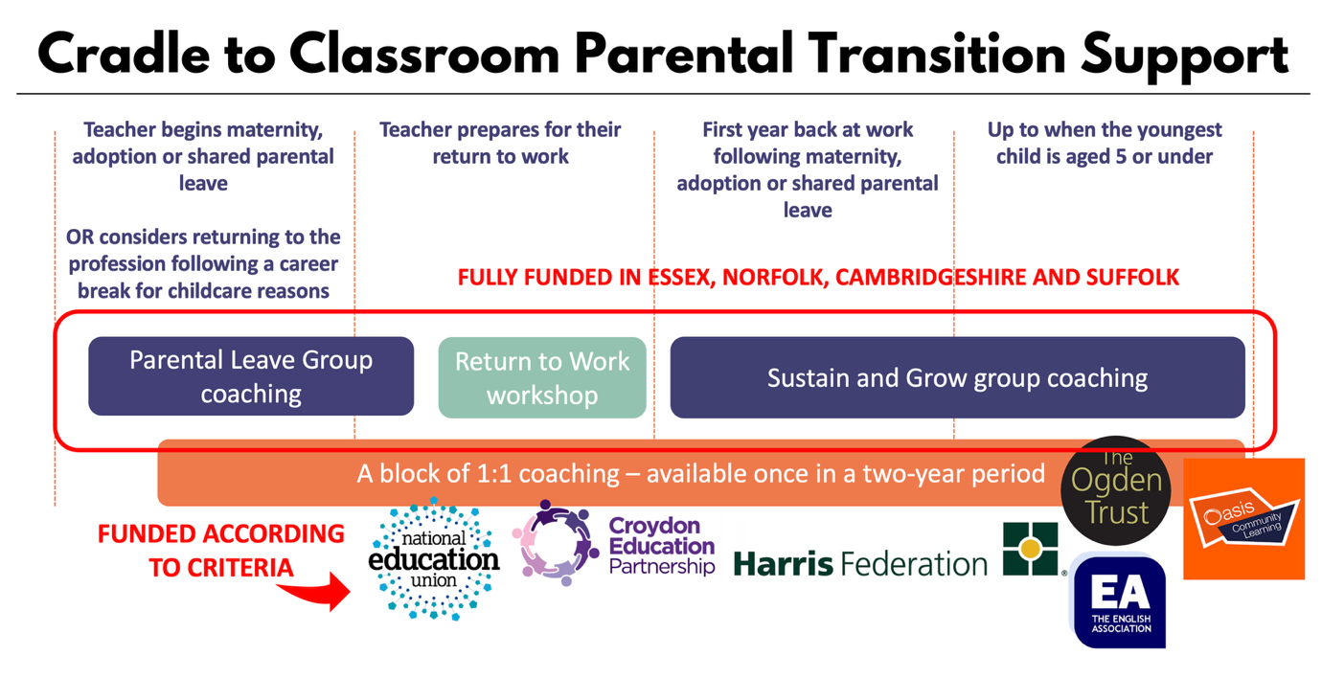

Contents

Page | Focus | Format | When to Use It? | Where to Use It?
3 | Allocations and Engagement
5 | Key Marketing Insights
6 | Full list of dates, raw links and social media handles
10 | HR / “New to The MTPT Project” Information Event | Email Content | December / January | Direct emails to HR / SBMs / school leaders
11 | Spring Update | Blog | January | Newsletters  Websites  Pregnancy and Maternity, Adoption, Shared Parental Leave Policies
13 | Spring Update | Social Media | January / February | LinkedIn / Instagram / BlueSky / Facebook
15 | Sustain and Grow group coaching | Case Study  Not currently available in this region – to be updated for Spring 2026 | January | Newsletters
16 | Sustain and Grow group coaching | Email Content | December / January | Direct emails to colleagues with children aged 5 or younger
17 | Sustain and Grow group coaching | Social Media | December / January | LinkedIn / Instagram / BlueSky / Facebook
18 | Parental Leave group coaching | Case Study – NEW CONTENT | Spring term | Newsletters  Websites  Pregnancy and Maternity, Adoption, Shared Parental Leave Policies
19 | Parental Leave group coaching | Email Content | A month before the colleague begins leave  3 months into their leave period  KIT day communications  Mention the opportunity a maximum of twice unless the colleague brings it up themselves | Direct emails to colleagues approaching / on a period of leave
20 | Parental Leave group coaching | Social Media | Once per half term from December onwards | LinkedIn / Instagram / BlueSky / Facebook
21 | Return to Work workshops | Case Study – NEW CONTENT | January  March | Newsletters  Websites  Pregnancy and Maternity, Adoption, Shared Parental Leave Policies
23 | Return to Work workshops | Email Content | Two months ahead of a colleague’s return to work  KIT day communication  Mention the opportunity a maximum of twice unless the colleague brings it up themselves | Direct emails to returning staff
24 | Return to Work workshops | Social Media | Every 2-3 weeks from January onwards | LinkedIn / Instagram / BlueSky / Facebook

Allocations and Engagement – Autumn 2025

Why are some logos on some fliers, and not others? Our branding is allocated according to the funding contribution of each organisation:

- £618 + - logo on all three programmes
- > £618 – logo on Return to Work workshops and either Sustain and Grow or Parental Leave group coaching programme
- > £375 – logo on Return to Work workshops

Break-Even Figures

Break-even figures are calculated according to the total contribution in each region. These represent the minimum target engagement for the whole of 2025-26 but there is no upper limit to participation thanks to virtual (live) and recorded access.

Region | Funder | Parental Leave group coaching | Return to Work workshops | Sustain and Grow
Suffolk | Unity TSH | 2 | 6 | 1
Norfolk | Inspiration TSH  Julian TSH | 4 | 6 | 2
Essex | Chafford Hundred TSH  Saffron TSH | 2 | 7 | 1
Cambridgeshire | Cambridgeshire Secondary Heads | 2 | 3 | 1

There is flexibility in these break break-even figures. For example:

- If two participants on our Sustain and Grow group coaching programme are from Suffolk, this cancels out the Parental Leave group coaching funding.

- If four participants on our Parental Leave group coaching programme are from Essex, this cancels out the Sustain and Grow funding.

- If nine participants on our Return to Work workshops are from Cambridgeshire, this cancels out either the Parental Leave group coaching funding or the Sustain and Grow group coaching funding.

As of 8th December, 10 participants in the East of England have benefited from one of our Cradle to Classroom programmes:

Region | Funder | Parental Leave group coaching | Return to Work workshops | Sustain and Grow
Suffolk | Unity TSH | 0 | 0 | 1
Norfolk | Inspiration TSH  Julian TSH | 0 | 2 | 0
Essex | Chafford Hundred TSH  Saffron TSH | 0 | 1 | 1
Cambridgeshire | Cambridgeshire Secondary Heads | 1 | 2 | 2

Key Marketing Insights:

- During Autumn 1, participants have heard about the programmes through three main channels: MTPT communication, School / MAT communication (e.g. newsletter, briefing) or have been recommended by a friend

Opportunities
The East of England is where we are seeing lowest engagement on our programmes. Sign up for December and January cohorts is positive in Essex, but we are seeing little engagement in Suffolk and Norfolk.

We need to get The MTPT Project (i.e. Emma) in front of school leaders in these regions to outline the programmes and their importance to the health of our workforce.

Projected Engagement
Sign ups for the January Sustain and Grow group coaching programme and February Return to Work workshops indicate that more could be done to promote these opportunities in Suffolk and Norfolk.

Projected sign up for our Sustain and Grow group coaching programme indicates that Essex and Cambridge will be in positive figures by January.

Target groups
The MTPT Project are proud to create inclusive and diverse communities of support for our parent-educator community. This is achieved through closely reviewing who is accessing our programmes. This term we know that…

- Just 4% of participants on the three programmes thus far are members of support staff. This figure should be closer to 40%. Please make it very clear to pastoral, support and central Trust staff, that the Cradle to Classroom programmes are also for them!

- We are delighted that an increasing number of fathers are engaging with our programmes – please keep sharing our Sustain and Grow group coaching programme with all fathers to children aged 5 or under, and our Parental Leave group coaching / Return to Work workshops with fathers who have taken a period of extended paternity, adoption or shared parental leave

- In 2024-25 colleagues from racially minoritised backgrounds were over-represented on our programmes in comparison to the wider teacher workforce. We are not yet seeing the same trend this year, so please do empower your colleagues to join us.

Want to chat further?
Please book in a time to discus your marketing strategy with me at www.calendly.com/emmasheppard if you represent one of our funding schools / TSHs / NEU districts.

Upcoming Event Dates 2025-26

Autumn

Sustain and Grow (Tuesday) – 15:30-16:30 (ongoing)
- Tuesday 23rd September
- Tuesday 14th October
- Tuesday 25th November
- Tuesday 13th January
- Tuesday 10th February
- Tuesday 10th March

Sustain and Grow (Thursday) – 15:30-16:30 (ongoing)
- Thursday 25th September
- Thursday 16th October
- Thursday 27th November
- Thursday 15th January
- Thursday 12th February
- Thursday 12th March

Parental Leave group coaching (Winter) – 09:30-10:30 (ongoing)
- Tuesday 9th December
- Tuesday 6th January
- Tuesday 3rd February

Spring

Sustain and Grow (Tuesday) – 15:30-16:30
- Tuesday 20th January
- Tuesday 24th February
- Tuesday 24th March
- Tuesday 21st April
- Tuesday 19th May
- Tuesday 16th June

Sustain and Grow (Thursday) – 15:30-16:30
- Thursday 22nd January
- Thursday 26th February
- Thursday 26th March
- Thursday 23rd April
- Thursday 21st May
- Thursday 18th June

Return to Work Workshop – 09:30-11:00
- Thursday 5th February

Parental Leave group coaching (Spring) – 09:30-10:30
- Monday 16th March
- Monday 13th April
- Monday 11th May

Return to Work Workshop – 09:30-11:00
- Monday 23rd March

Summer

Parental Leave group coaching (Summer 1) – 09:30-10:30
- Tuesday 5th May
- Tuesday 2nd June
- Tuesday 30th June

Return to Work Workshop – 09:30-11:00
- Tuesday 12th May

Return to Work Workshop – 09:30-11:00
- Monday 22nd June

Parental Leave group coaching (Summer 2) – 09:30-10:30
- Thursday 2nd July
- Thursday 30th July
- Thursday 27th August

Return to Work Workshop – 09:30-11:00
- Thursday 16th July

Raw Links

Details of the full Cradle to Classroom programme: www.mtpt.org.uk/coaching

Parental Leave group coaching programme: https://www.eventbrite.co.uk/cc/mtpt-parental-leave-group-coaching-cohorts-3435509

Return to Work workshops: https://www.eventbrite.co.uk/cc/mtpt-return-to-work-workshops-3435429

Sustain and Grow group coaching: https://www.eventbrite.co.uk/cc/sustain-and-grow-group-coaching-3463389

1:1 Coaching: https://docs.google.com/forms/d/1vKh4qFh0TQXU9WMrqWmycHgbA4APrOxkO5UrAI11ziA/

Regionally branded fliers: https://www.mtpt.org.uk/cradle-to-classroom-fliers

Social Media Handles

Instagram: @mtptproject
BlueSky: @mtptproject (for signposting only – we do not use BlueSky much)
LinkedIn: https://www.linkedin.com/company/the-mtpt-project/
Facebook: tag @The MTPT Project

Please note: The MTPT Project can be tagged on X @mtpt_project but we no longer use this social media platform.

HR / “New to The MTPT Project” Information Video (Email Content)

For December / January:

Dear…

[FUNDER] are very excited to be supporting The MTPT Project’s Cradle to Classroom programme of parental transition support this academic year.

The programme consists of coaching and workshop opportunities to support colleagues over the parental leave and return to work period.

In the Autumn term alone, 10 colleagues in the East of England benefited from one of these brilliant programmes.

An information video about the programme is available here: https://youtu.be/P2-yxkxh3R4

Please do watch it to learn more about the offer and begin sharing in your networks.

Spring 2025 Update Blog

[FUNDER] Celebrates Powerful Partnership with The MTPT Project

Ten colleagues in the East of England have benefited this year from one of The MTPT Project’s Cradle to Classroom programmes, as part of [FUNDER’S] offer to colleagues during, and following the parental leave period.
“The programme empowered me to find answers within myself. At the end of my maternity leave, I applied for and secured a new role! It has given me such confidence in my ability to return to work.” – Secondary English Teacher, Summer Parental Leave group coaching cohort, 2025

This partnership gives state school colleagues fully-funded access to three coaching and workshop offers designed to support them as they navigate their parenting journey:

- Group coaching during the parental leave period
- Return to Work workshops
“The workshop encouraged us to connect with each other, making me feel less isolated about returning to work. We had time to think about our values, strengths and how our experiences as parents actually add to our professional lives. It was brilliant!” – Trust Leader, October 2025 Return to Work workshop
- Group coaching (Sustain and Grow) for colleagues back at work with children aged 5 or younger

Cohorts and workshops run throughout the academic year, and recorded access is available to support those who cannot make the live dates.

Becoming a parent is a joyful moment in our colleagues’ lives, but this time can come with challenges, and too many educators find it difficult to manage the balance between family life and a career that they love. This is why we see – year on year – thousands of mothers aged 30-39 leaving the classroom.
“I absolutely love the flexibility this programme offers. The sessions are really helpful and come just at the right time.” – Primary Headteacher, September 2024 Sustain and Grow cohort

[FUNDER] recognises the importance of supporting colleagues over this key period where more than 67% of teachers become parents. We want colleagues in our region to know how valuable they are to our schools, and to feel empowered to design careers that fit in with their new family lives.

The MTPT Project’s Cradle to Classroom programme is designed to specifically address the challenges faced by colleagues at different stages of their parenting journeys. The coaching and workshops are positive, empowering and offer participants the tools to fully enjoy both their personal and professional lives.

Explore the upcoming opportunities available to you and your colleagues on Eventbrite, and keep up to date by signing up to [FUNDER’s] newsletter, following us on [SOCIALS] or signing up to The MTPT Project’s fortnightly bulletin.

Spring Update Social Media

Instagram: @mtptproject
BlueSky: @mtptproject (for signposting only – we do not use BlueSky much)
LinkedIn: https://www.linkedin.com/company/the-mtpt-project/
Facebook: tag @The MTPT Project

Please note: The MTPT Project can be tagged on X @mtpt_project but we no longer use this social media platform.

Accompanying Image: C2C flier

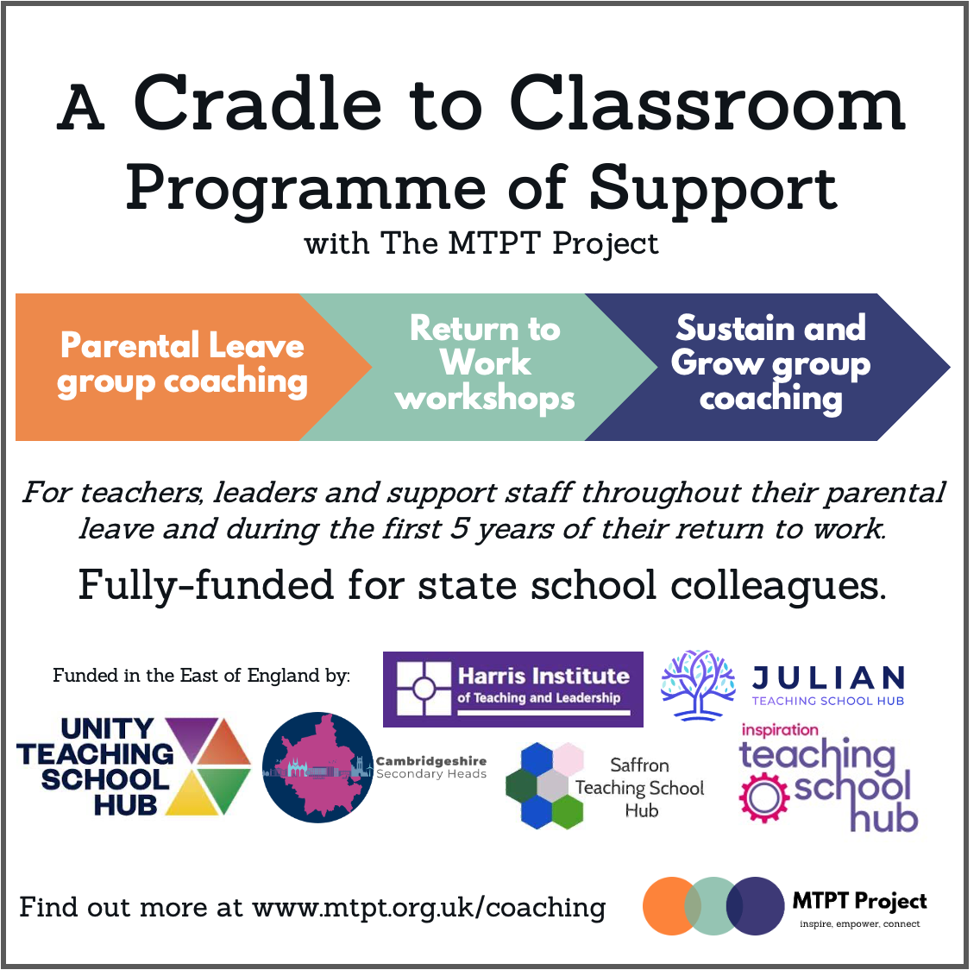

Instagram / BlueSky / X:

The @mtptproject’s Cradle to Classroom programme of parental transition support continues this term with further group coaching and return to work support. Fully-funded for state school colleagues in the East of England! Find out more at www.mtpt.org.uk/coaching

OR Find out more at [LINK TO SPRING 2025 UPDATE BLOG]

LinkedIn / Facebook:

[FUNDER] commits to ongoing support for parent-colleagues!

Colleagues on a period of parental leave, returning to work or balancing their school commitments with young children can continue to benefit from fully-funded support this Spring term thanks to an ongoing partnership between [FUNDER] and @The MTPT Project.

Our partnership gives state school colleagues fully-funded access to The MTPT Project’s Cradle to Classroom programme of transition support – three coaching and workshop offers designed to support them as they navigate their parenting journey:

- Group coaching during the parental leave period
- Return to Work workshops
- Group coaching (Sustain and Grow) for colleagues back at work with children aged 5 or younger

Find out more at www.mtpt.org.uk/coaching

OR Find out more at [LINK TO SPRING 2025 UPDATE BLOG]

Sustain and Grow (Standalone Case Study) – currently unavailable in this region

Sustain and Grow group coaching (Email Content)
Adapt as you see fit according to your relationship with the recipient.

Dear…

As we are coming into the spring term, I wanted to draw your attention to a fully-funded coaching offer that starts at the end of January that may be of interest to you.

The MTPT Project are the UK’s charity for parent-educators, and they run a six-month group coaching programme called Sustain and Grow for teachers, leaders and support staff who are parents.

The programme is completely optional, and absolutely nothing to do with any of our performance management at [SCHOOL / TRUST]. It is all about empowering you and giving you the time and headspace to explore topics that are relevant to you as a parent and professional, and set goals that are meaningful for your home and work life.

The programme has been running since 2023, and has received lots of positive feedback from participants around finding a sense of balance, setting boundaries and generally feeling uplifted and supported. It counts as professional and personal development and comes with a certificate at the end from The MTPT Project.

As your youngest child is less than 5 years old, you can access the programme, which is fully-funded by [FUNDER].

Cohorts run on Tuesdays and Thursdays between 3:30-4:30pm on Zoom, so you can see if the dates work for you and your other commitments on Eventbrite: https://www.eventbrite.co.uk/cc/sustain-and-grow-group-coaching-3463389 Hybrid and recorded access is also available so you can access the programme in whatever ways works best for you.

You can sign up directly without going through me / anyone else at school, but I’d love to know if you choose to go ahead with it.
Sustain and Grow Social Media

Instagram: @mtptproject
BlueSky: @mtptproject (for signposting only – we do not use BlueSky much)
LinkedIn: https://www.linkedin.com/company/the-mtpt-project/
Facebook: tag @The MTPT Project

Please note: The MTPT Project can be tagged on X @mtpt_project but we no longer use this social media platform.

Accompanying Image: SG flier

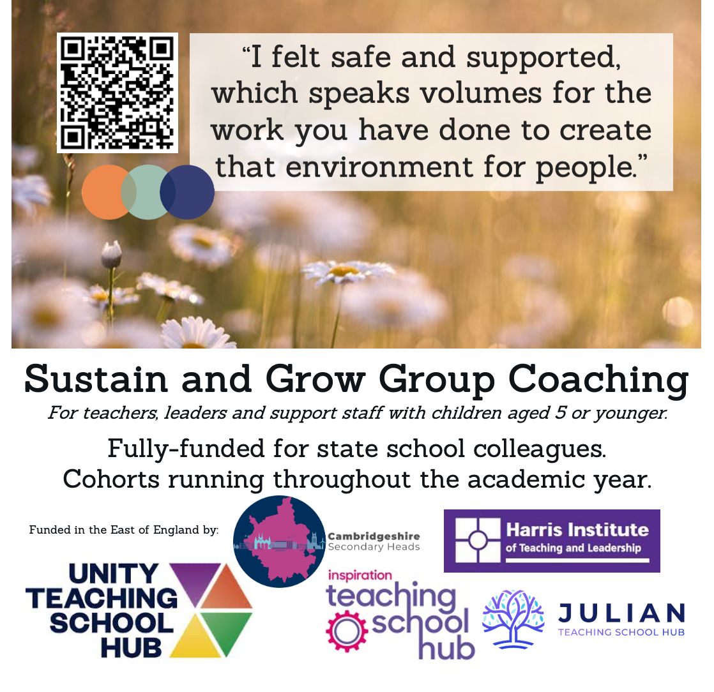

Instagram / BlueSky / X:

January cohorts of the @mtptproject’s Sustain and Grow group coaching programme begin on Tuesday 20th / Thursday 22nd January. Fully-funded for state school colleagues in England who have children aged 5 or younger. Find out more at: https://www.eventbrite.co.uk/cc/sustain-and-grow-group-coaching-3463389

LinkedIn / Facebook:

@The MTPT Project’s Sustain and Grow group coaching programme begins on Tuesday 20th / Thursday 22nd September.

This fully-funded programme offers state school colleagues with children aged 5 or younger six sessions of group coaching between January and June.

Find out more at: https://www.eventbrite.co.uk/cc/sustain-and-grow-group-coaching-3463389

Parental Leave Group Coaching (Standalone Case Study) – NEW CONTENT

As part of a regional partnership in the East of England, [FUNDER] are proud to be supporting The MTPT Project’s Cradle to Classroom programme of parental transition support throughout the academic year 2025-26.

The programme allows teachers, leaders and support staff working in state schools to access fully-funded group coaching and workshop support from the start of their parental leave all the way up to when their youngest child is 5 years old.

Almost 20,000 teachers are on a period of maternity, adoption or shared parental leave at any given time, representing approximately 5% of the total workforce – a huge life change that comes with a new sense of identity and evolving values.

Since 2023, the Parental Leave group coaching programme, part of The MTPT Project’s Cradle to Classroom programme, has ensured that – for more than 160 new parents – this transition has been positive and empowering.

Isabel*, a Maths teacher based in Cambridgeshire completed a recorded version of the Parental Leave group coaching programme between September and November 2025 to prepare for her return to work in the Autumn term. She said: “Thank you for making me feel like a professional again. The probing questions really made me think deeply about my goals in a way I would have struggled to do alone.”

Isabel used the coaching to explore her career path and set goals for her future that aligned with her priorities and new values as a working parent.

She said the flexible nature of the programme, which offers live, hybrid and recorded access had a “huge impact”, as she was not able to attend all three live dates.

Ensuring all three elements of the Cradle to Classroom programme are fully-funded for state school colleagues is just one of the ways that [FUNDER] is addressing the recommendation in the recent Missing Mothers report by The New Britain Project and The MTPT Project, which called for “a comprehensive coaching programme for mothers during, and post-maternity leave”.

Dates of upcoming Parental Leave group coaching cohorts and other regional sponsors can be found on Eventbrite.

A full outline of the Cradle to Classroom programme of parental transition support can be found on The MTPT Project’s website.

*Name changed to protect this colleague’s privacy

Parental Leave group coaching (Email Content)
Adapt as you see fit according to your relationship with the recipient.

Dear…

Congratulations on your upcoming leave / I hope that this email finds you well and enjoying maternity / adoption / shared parental leave. [Add something personalised here if appropriate].

I’m getting in touch to draw your attention to a fully-funded coaching offer that may be of interest to you during your leave.

The MTPT Project are the UK’s charity for parent-educators, and they run a three-month group coaching programme called for colleagues currently on maternity, adoption or shared parental leave.

The programme is completely optional, and designed to support you personally during your leave, giving you some “me time” for your own thoughts and goals. It has received lots of positive feedback from previous participants who have used it as a way to stay connected with other educators during their leave and explore their new identities as parents. It counts as professional and personal development and comes with a certificate at the end from The MTPT Project.

There are live, hybrid and recorded options to complete the programme, which takes place on Zoom and is fully-funded by [FUNDER].

You can see the dates of upcoming cohorts on Eventbrite: https://www.eventbrite.co.uk/cc/mtpt-parental-leave-group-coaching-cohorts-3435509

You can sign up directly without going through me / anyone else at school, but please feel free to share or celebrate anything you’d like with us as we stay in touch during your leave.

Parental Leave Social Media

Instagram: @mtptproject
BlueSky: @mtptproject (for signposting only – we do not use BlueSky much)
LinkedIn: https://www.linkedin.com/company/the-mtpt-project/
Facebook: tag @The MTPT Project

Please note: The MTPT Project can be tagged on X @mtpt_project but we no longer use this social media platform.

Accompanying Image: PLGC flier



Instagram / BlueSky / X:

Colleagues currently on a period of maternity, adoption or shared parental leave can enjoy fully-funded access to @mtptproject’s Parental Leave group coaching programme. Find out more at: https://www.eventbrite.co.uk/cc/mtpt-parental-leave-group-coaching-cohorts-3435509

LinkedIn / Facebook:

Colleagues currently on a period of maternity, adoption or shared parental leave can enjoy fully-funded access to @themtptproject’s Parental Leave group coaching programme.

Live, recorded or hybrid access to the programme gives you an hour of “me time” each month to consider your own identity, reflections and goals with a supportive cohort of parent-educators.

Spring / Summer cohorts begin in March, May and June and are fully-funded for state school colleagues by [FUNDER]. Find out more at: https://www.eventbrite.co.uk/cc/mtpt-parental-leave-group-coaching-cohorts-3435509

Return to Work Workshops (Standalone Case Study)

As part of a regional partnership in the East of England, [FUNDER] are proud to be supporting The MTPT Project’s Cradle to Classroom programme of parental transition support throughout the academic year 2025-26.

The programme allows teachers, leaders and support staff working in state schools to access fully-funded group coaching and workshop support from the start of their parental leave all the way up to when their youngest child is 5 years old.

New data provided by the DfE shows that this is the time when educators are at greatest risk of leaving the profession, with almost 4,000 teachers lost within the first four years of their return from maternity leave.

Findings from TeacherTapp revealed that ‘there is a big gap in support for teachers coming back from leave. Many said they felt forgotten, out of the loop, or like a spare part when they returned’, and as a result, ‘returning to work can feel ‘messy’’.

The New Britain Project and The MTPT Project’s Missing Mothers report found that only 38% of mother-teachers surveyed were satisfied with the maternity leave and transition support provided by their school.

Since 2023, The MTPT Project’s Cradle to Classroom programme has already changed this narrative for more than 700 new parents and colleagues with young families, including 50 participants based in the East of England.

The 90-minute interactive Return to Work workshops, which run seven times throughout the year, offer participants the chance to prepare logistically and emotionally for a confident return to work.

Elisabeth, School Improvement lead based in Norfolk attended a Return to Work workshop in December 2025.

Elisabeth said the workshop offered “really supportive, practical advice and important information about the legalities of the return to work period”. She “loved the plate analogy for the coaching segment and talking to other senior leaders in the breakout rooms”.

Elisabeth left the workshop with greater clarity around her boundaries, and the support available from her family, friends and colleagues as well as a clear idea of her entitlements as a working parent.

Ensuring all three elements of the Cradle to Classroom programme are fully-funded for state school colleagues is just one of the ways that [FUNDER] is helping to improve working conditions for staff at this important point in their personal lives.

Upcoming Return to Work workshop dates and other regional sponsors can be found on Eventbrite.

A full outline of the Cradle to Classroom programme of parental transition support can be found on The MTPT Project’s website.

Return to Work workshop (Email Content)
Adapt as you see fit according to your relationship with the recipient.

Dear…

We are really looking forward to seeing you on your next KIT day / when you return to work in the coming weeks / months. [Add something personalised here if appropriate.]

To support you as you make this big transition, could I draw your attention to the fully-funded Return to Work workshops run by The MTPT Project, the UK’s charity for parent-educators?

The workshop highlights your legal entitlements as a returning parent and offers you some group coaching space to explore your emotional and logistical preparation ahead of your return. It also gives you the chance to meet other educators who are also returning to work soon to share your experiences.

The workshop is completely optional, fully-funded by [FUNDER] and can be completed at home [or when you are in school for a KIT day on [DATE]]. There are live and recorded access versions available, and feedback from previous participants has been really positive.

The next live workshop takes place on Thursday 5th February / Monday 23rd March. More information is available on Eventbrite: https://www.eventbrite.co.uk/cc/mtpt-return-to-work-workshops-3435429

You can sign up directly without going through me / anyone else at school, but do let me know if you’d like to book in a meeting to discuss any questions that arise from the workshop if you do choose to attend.

Return to Work workshop Social Media

Instagram: @mtptproject
BlueSky: @mtptproject (for signposting only – we do not use BlueSky much)
LinkedIn: https://www.linkedin.com/company/the-mtpt-project/
Facebook: tag @The MTPT Project

Please note: The MTPT Project can be tagged on X @mtpt_project but we no longer use this social media platform.

Accompanying Image: R2W flier

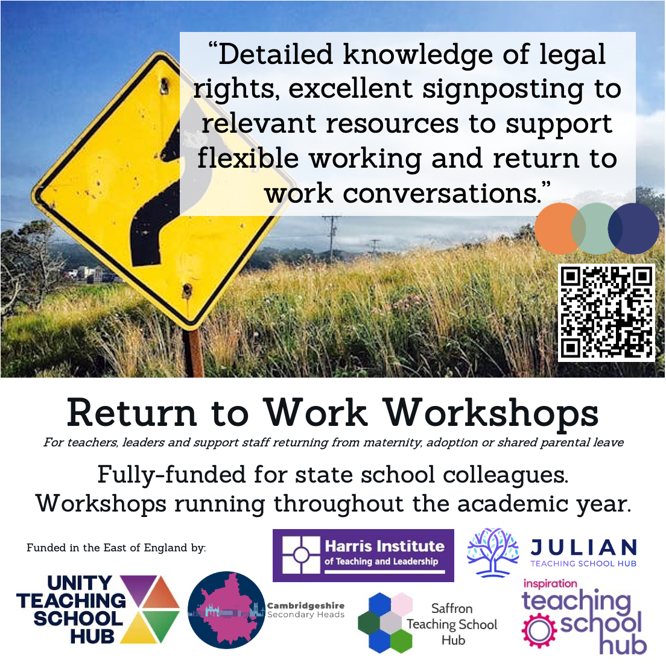

Instagram / BlueSky / X:

Colleagues preparing to return to work following a period of maternity, adoption or shared parental leave can enjoy fully-funded access to @mtptproject’s Return to Work workshop on Thursday 5th February / Monday 23rd March. Live and recorded access are available.

Find out more at: https://www.eventbrite.co.uk/cc/mtpt-return-to-work-workshops-3435429

LinkedIn / Facebook:

Colleagues preparing to return to work following a period of maternity, adoption or shared parental leave can enjoy fully-funded access to @themtptproject’s Return to Work workshop on Thursday 5th February / Monday 23rd March.

This 90 minute webinar shares key legal information and gives you the space to emotionally and logistically prepare for a confident return. Live and recorded access are available, fully-funded by [FUNDER].

If you’ve got colleagues returning to work this half term, this is a brilliant way to show them they are valued and offer them practical support as they make this big transition.

Find out more at: https://www.eventbrite.co.uk/cc/mtpt-return-to-work-workshops-3435429

